Mendelian Genetic Crosses of Wisconsin FastPlants, Brassica rapa

Parental Cross: Green Leaf, Non-Purple Stem X Yellow-Green Leaf, Purple Stem

F₁: Green Leaf, Purple Stem

F₁ Cross: Green Leaf, Purple Stem X Green Leaf, Purple Stem

F₂: ? (record phenotypes observed).

In your lab notebook, do the following once the F₂ generation is grown to flower stage:

1) Tally and categorize the F₂ plants by phenotype. How many different phenotypes are there? How many plants of each phenotype?

2) If the individuals of the Parental Cross were all homozygous for their two traits, predict the genotypes of the parental, F₁ and all F₂ phenotypes.

3) Based on your F₁ and F₂ genotype predictions in (2),
a) What is the mode of inheritance of leaf and stem color (sex-linked, codominance, incomplete dominance, dominant-recessive… etc.)?
b) Assign letters for the alleles based on your answer to (a).
c) Rewrite the F₁ cross using the genotypes of the F1 parents assigned in (b).
d) Solve for the F₂ phenotypic ratio you would expect from the F₁ cross and
show your work.

4) Complete a Chi Square analysis table to determine if the observed ratio of offspring in each of your phenotypic categories in (1) are the same as the expected ratio of offspring you predicted in 3(d). (Refer to the Mitosis Lab for Chi Square instructions.)
a) What is your experimental hypothesis regarding the mode of inheritance (tell what phenotypes are dominant and which are recessive), the genotypes of the original parents and F₁ individuals, and the phenotypes and phenotypic ratio of the observed F₂ generation?
b) What is the statistical null and alternate hypothesis for Chi Square
analysis?
c) Create and fill out a Chi Square calculations table (as in the Mitosis Lab).
d) Determine the degrees of freedom and Chi Square table value at the 0.05 level of probability (refer to the Mitosis Lab or online).
e) Do you accept the null or alternate hypothesis and why? What does this mean for your experimental hypothesis? If necessary, revise your experimental hypothesis and run through the Chi Square analysis again.
f) What is your final conclusion about the genotypes of the P, F₁ and F₂ generations and the mode of inheritance of the two traits: leaf color and stem color? What did you predict the genotypes and mode of inheritance would be and can you conclude these predictions are accurate?
g) If your experimental hypothesis was not proven correct, explain why not – is the leaf color data or the stem color data to blame? Do this by using separate punnet squares for leaf color and stem color data and evaluate each punnet square’s prediction of the expected phenotypic ratio with its own Chi Square analysis to prove which observed phenotypic ratios, for leaf color or for stem color, are incorrect meaning they do not match the expected ratio predicted by the punnet square.
h) Once you uncover the “problem” ratio(s) do some online research about the expression of the “offending” leaf color or stem color trait(s) to explain why this apparent error might have occurred. Make sure you know the dates of when the seed was sown and the plants were observed before you start your research. Cite your source(s).

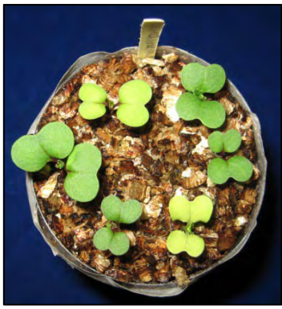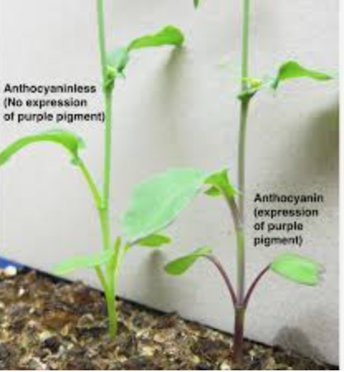
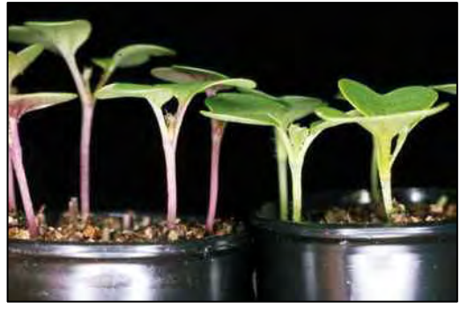
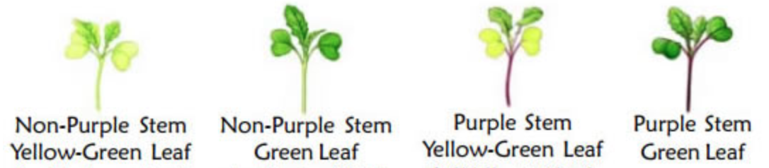

Purple Stem/Green Leaf
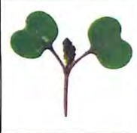

Purple Stem/Yellow Green Leaf
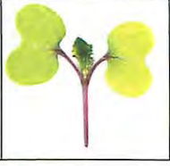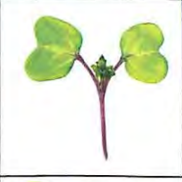
Non-Purple Stem/Green Leaf
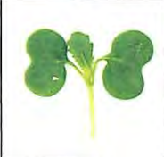

Non-Purple Stem/Yellow-Green Leaf

